EUGLOH Annual Student Research Conference
Global Health Challenges: Diseases of Modern Life
September 28th – 30th 2020
Organized by University of Szeged (Hungary)
with the participation of member universities of the EUGLOH Alliance:
Ludwig-Maximilian University of München (Germany)
Lund University (Sweden)
University of Porto (Portugal)
Paris-Saclay University (France)

WHAT CAN YOU EXPECT?
Are you interested in research about Global Health and Diseases of Modern Life? Do you want to share and discuss your research with students from all five EUGLOH member universities?
Then take part in the first EUGLOH Annual Research Student Conference!
100 Students selected from the five universities from all levels, (BSc to PhD), and from all faculties, will be able to present their scientific work, mentored by academic staff, during the online Annual Research Student Conference. Participants are expected to present their work in the form of an on line oral presentation or through an electronic poster session. The conference program also includes plenary talks by expert scientists of EUGLOH member universities.

WHICH TOPICS WILL BE COVERED?




The presentations will cover the students’ own work in all aspects of multidisciplinary sciences, with a primary focus on Global Health and Diseases of Modern Life:
- Environmental challenges related to water and food contamination
- Ageing and dementia as a global health challenge
- Effects of air pollution on health
- Global warming, climate change - related global health problems
- Non-communicable and pandemic diseases
- Health challenges related to population displacement
- Antimicrobial resistance
- High-threat pathogens
- Vaccine hesitancy
- Respiratory diseases
- Cardiovascular diseases

- Cancer screening and care
- Psychological and mental disorders
- New epidemics, including COVID-19
- Other global health challenges

WHO CAN PARTICIPATE?
Students: Bachelor, Master and PhD students from all faculties of member universities of the EUGLOH Alliance (University of Szeged, Paris-Saclay University, Lund University, Ludwig-Maximilian University of München, University of Porto).

WHAT ARE THE FORMATS OF PRESENTATION AVAILABLE?
Participating students can present their work in one of the two following ways:
Online oral presentations: lectures by online video streaming and interactive communication tools. The duration of each presentation cannot exceed 10 minutes. The presentation will be followed by a 5-minute discussion.
Electronic offline presentation: pre-recorded 3-minute presentations in a common video file format uploaded on the e-presentation platform. Video files will be published prior to interactive live discussion sessions that will be organized to evaluate the quality of the work as well as presentation skills.
10 online oral presentations and further 10 electronic offline presentations can be nominated by each participating partner university.

HOW ARE PRESENTATIONS EVALUATED AND REWARDED?
Students’ presentations will be evaluated by an evaluation committee to assess the following:
- quality of the abstract,
- scientific value of presented results,
- format, illustration, coherence, and style,
- discussion skills and professional competence.
Awards will be provided in each education level separately and will be presented at the closing ceremony. EUGLOH Certificates and 4 ECTS will be provided for presenting students.

WHERE CAN YOU GET INFORMATION?
General information: eugloh@rekt.szte.hu
Academic program: Prof. Ferenc Peták, Department of Medical Physics and Informatics, University of Szeged (EUGLOH, academic leader of Work Package for Research and Innovation), petak.ferenc@med.u-szeged.hu
Administrative support: Eszter Sasi-Pokriva, sasi-pokriva.eszter@med.u-szeged.hu

WHERE CAN YOU REGISTER AND SUBMIT AN ABSTRACT?
As a first author you can register and submit your abstract here:
http://www3.szote.u-szeged.hu/eugloh/
Registration of co-authors and the members of audience is here:
https://modulo.etr.u-szeged.hu/Modulo2/default/en/invitation/b69b1b35-16b6-4bb2-93d3-db1e712ae247
Upon successful submission, the first authors and their supervisors will receive a confirmation e-mail. Maximum of three students can author the abstract and the number of supervisors is limited to three.
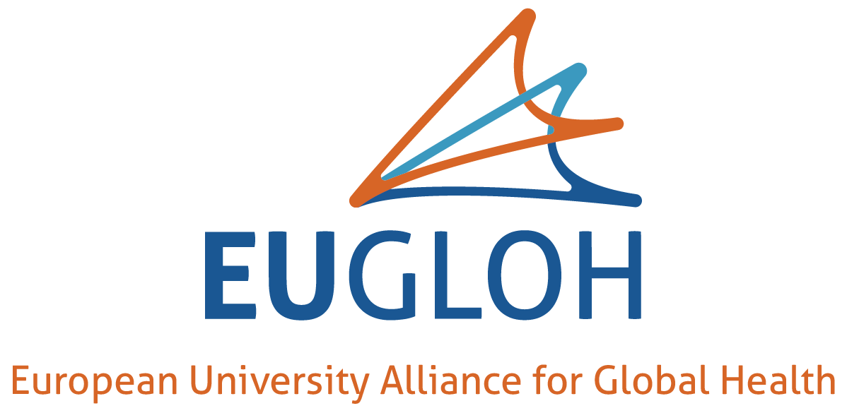
Abstract submission deadline: September 7th, 2020.
www.eugloh.eu

