
Dóra Hangya
hangyadora@gmail.com

PROFESSIONAL EXPERIENCE

2015 July – present
head of HR services

Name of the employer: Hungarian Association of the Deaf and Hard of Hearing (SINOSZ)

Main tasks and responsibilities:
My Objective to find the best way for the companies to employ people with disabilities using the newest HR solution.

- Managing the office of HR services (monitor and coordinate the HR services in the whole country)
- Managing recruitment and selection of unemployed, people with disability
- Vocational rehabilitation: reintegrate jobless people with disability to the labour market
  - disclose jobs for employees with disability
  - coach, develop people with disability for the work and labour market
  - motivate, incrase potentiality & competence of jobless people with disability
  - Follow-up
- Connect with employers; organizational development
Main reference: Mercedes-Benz Manufacturing Hungary Kft., Szerencsejáték Zrt., Auchan Magyarország Kft., Flextronics International Kft., British Petrol, IKEA Industry Magyarország Kft., Nolato Magyarország Kft., TESCO Globál Áruházak Zrt.
- Managing CSR projects of employers (civil relations, volunteer programs, accessibility, responsible employment, CSR Hungary award, Disabled Friendly Workplace award)
Main reference: Szerencsejáték Zrt., Auchan Magyarország Kft., GE (General Electric), Flextronics International Kft.
- Keeping in touch with decision-makers (EMMI, government offices, NRSZH), make professional materials, amendment of a laws, advocacy
- Vocational rehabilitation consulting for employers (recruitment, selection, OD, Employer Branding)
- Create the first, accessibility job search portal for deaf people (www.akadalyugras.hu)
- Make trainings for jobless people and for employers
- Training for managers (Developing leadership skills about equality, diversity management, occupational safety and health, disabled workers, law of rehabilitation, disadvantaged groups of workers)

2011 September July – present
external lecturer
Name of the employer: University of Szeged Gyula Juhász Faculty of Education, Department of Adult Education
As an external lecturer I teaching socialandragogy, diversity management, disadvantaged groups in the labor market, (corporate) social responsibility, rehabilitation, employment of people with disabilities, socialandragogy of elderly http://www.fk.jgytf.u-szeged.hu/tanszek/kozmuv/?page_id=722

2013 May– 2015 June
HR consultant and labour market specialist

Name of the employer: Hungarian Association of the Deaf and Hard of Hearing (SINOSZ)

Main tasks and responsibilities:
- Contact with jobseekers (Labour-market reintegration: motivate and coach jobless people how find a work, upgrading jobless people's knowledge of job-finding, and change their attitude of working, career advising / vocational guidance)
- Make trainings for jobless people and for employers
- Contact with employer partners; vocational rehabilitation consulting for employers (recruitment, selection, OD)
- Managing recruitment and selection of unemployed, people with disability
- Project management
- Professional consulting (HR, Vocational rehabilitation, rehabilitation law)
- Training for managers (Developing leadership skills about equality, diversity management, occupational safety and health, disabled workers, law of rehabilitation, disadvantaged groups of workers)

2011 October – 2013 April
county secretary

Name of the employer: Hungarian Association of the Deaf and Hard of Hearing (SINOSZ), Szeged

Main tasks and responsibilities:
Contact with employer and education partners, coordination sign language courses and trainings, financial administration, contact with local organisations in Csongrád county, tender writing, labour intermediation, event management, client service, mentoring deaf and hard of hearing people, ISO system documentation

2011 July – 2011 September
training assistant
Name of the employer: Euromenedzser Consulting and Training Center, Szeged
Main tasks and responsibilities:
creating and repossessing training packages, creating presentations related to the curriculum, training check list compilation, preparing training sites, using interactive table, handling its content, producting certificate of delivery, managing tender documents, liaise with partners, training organization, accreditation, creating and handling training documents (attendance, counting and recognizing the statement of measuring prior knowledge, certificates, customer feedback questionnaires, trainer self-evaluations, checklists, training program, adult educational contract), create records, assistant director duties, creating and using negotiation checklists and protocols, managing accounts, filing incoming letters and e-mails

Trainee programs 2009-2011
- Trenkwalder, Szeged – HR trainee (recruitment, selection)
- Government Office Employment Center – Kiskőrös (HR trainee - TÁMOP 1.1.3 EU program)

EDUCATION
2016-2017 law faculty graduate HR consultant
(main specialisation: labour law)
University of Szeged Faculty of Law and Political Sciences
Other experience and further trainings:

- Development Equality competencies for managers
- Corporate equality rapporteur
- Vocational rehabilitation expert
- Hungarian Sign Language B2

2014-2016 PhD absolutorium
Phd proposed in 2018
ELTE PhD Program at Educational Sciences

2009-2011 Adult & Continuing Education (Andragogy) MA
University of Szeged Gyula Juhász Faculty of Education, Department of Adult Education

2006-2009 Adult & Continuing Education (Andragogy) BA
University of Szeged Gyula Juhász Faculty of Education,
Department of Adult Education

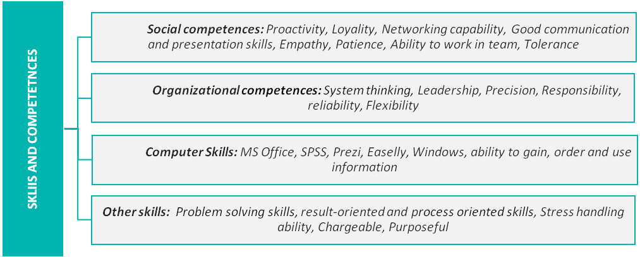
Professional skills: Training, Recruitment, HR consulting, OD, Rehabilitation Counseling, Adult Education, CSR, Research (Qualitative and Quantitative, online research), Equality & Diversity, Employer Branding, Vocational Rehabilitation, Disability management, Disability and Rehabilitation Law

LANGUAGE SKILLS

English
Professional

Hungarian sign language
Professional

German
Lectorate PhD written exam

SUPPLEMENTARY INFORMATIONS
I’m regularly take part in adult education as trainer, lecturer, researcher, curriculum developer.
Main references and works:
- TÁMOP - 2.2.4 - 11/1 - curriculum developer and trainer
- "EDUCOOP - Educational Cooperation for Disadvantages Children and Adults" IPA HuSrb, Szeged-Szabadka - Assistant research fellow and education expert, instruction expert, lecturer, curriculum developer
- TIOP 3.3.1 B-12/1-2012-0001– research methodology expert
- FSZK - Development Equality competencies for managers – trainer
- TÁMOP-1.4.3.-12/1-2012-0019 „– lecturer, curriculum developer
- SINOSZ Sign Language Interpreter vocational training - lecturer, curriculum developer (Modules: Rehabilitation, habilitation, Employment I-II.)
- „Közösen a Jövő Munkahelyeiért” Foundation, PhD scholarship 2015 - researcher
- SZTE ÁJTK EDUMAP project, 2016 – adult education expert

MAIN PUBLICATIONS:
- Farkas Éva - Farkas Erika - Hangya Dóra - Leszkó Hajnalka (2011): A Dél-alföldi régió akkreditált felnőttképzési intézményeinek működési jellemzői SZTE JGYPK FI
- Hangya Dóra (2011): Questions of Equal Opportunities in Adult Education: Legal Obligation vs. Practice, 7th Hungarian National and International Lifelong Learning Conference The Role of the Hungarian Higher Education in Achieving the Knowledge Triangle (Education-Research-Innovation). The Europe 2020 and the Education-Training 2020 Strategies, Veszprém p. 178-182
- Farkas Éva - Farkas Erika - Hangya Dóra - Kovács Anett – Kulcsár Nárcisz - Leszkó Hajnalka (2012): Az akkreditált felnőttképzési intézményeinek működési jellemzői SZTE JGYPK FI, 168.p.
- Hangya Dóra (2013): MENTORING EXPERIENCES OF DISADVANTAGED TARGET GROUPS Characteristics of Adult Training for the Disadvantaged and the Elderly, SZTE JGYPK, Szeged, p. 107.
- Hangya Dóra (2013): Hátrányos helyzetű célcsoportok mentorálási tapasztalatai A fogyatékossággal élők és az időskorúak felnőttképzési sajátosságai, SZTE JGYPK, Szeged, p. 111.
- Hangya Dóra (2016): "Esélyegyenlőségi útmutató" siket és nagyothalló személyek foglalkoztatásához

HONORS & AWARDS
- Outstanding student of the Faculty Award
- University of Szeged Faculty of Pedagogy and Psychology Andragogy MA 2011
- Scholarship of the Republic 2010-2011
- Urban Scholarship Szeged 2010-2011
- Board of Trustees of praise József Sófi Foundation
- OTDK I. place (National Scientific Students’ Associations Conference)

